# Durable Furnitures

Interlude Home

## Carousel Chandelier

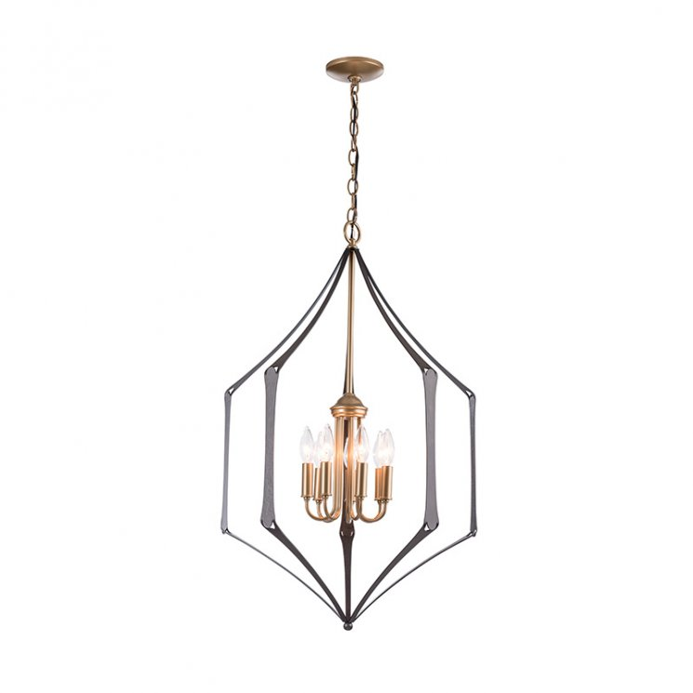

Calling to mind warm childhood memories, the Carousel Chandelier features a flawless geometric silhouette reminiscent of the cherished carnival ride. Six small candelabra lights nestle along the inner form casting a soft light that reflects and glistens off of the hand-forged steel surrounding it. Take a step back into your treasured past every time you sit down to a meal and admire the twinkling illumination that a Carousel Chandelier adds to your dining area.